CHAPTER 15
Tying It Together and Robots
THIS IS THE LAST CHAPTER of Part Three, and in this I wanted to bring various concepts together to enable you to approach your audit automation needs from the perspective of a combination of various capabilities. In addition, I will provide a short introduction to robots.

CYCLES OF AUDIT
Both audit and forensic inquiry often require digging deeper into various accounts. Machine learning improves accounting estimates (Ding et al., 2019). Accounting estimates are a critical part of financial statement generation. However, estimation errors impact financial reports. Ding et al. found that machine learning techniques can improve estimates and enhance the usefulness of financial information. Estimation includes accruals and other adjustments (Chen and Li, 2013). In this chapter we will take a look at various automations of processes in accordance with different cycles.
We approach it through the lens of the Infinity Cycle. In Figure 15.1, the left loop, that is, the operations loop has three cycles: Revenue Cycle, Production Cycle, and Procurement/SC Cycle. The Investment Loop has three cycles: Financing, M&A, and Capital Structure Management.
The Control Loop has Planning, Strategy, Governance, Incentives and Compensation, and Capital Allocation.
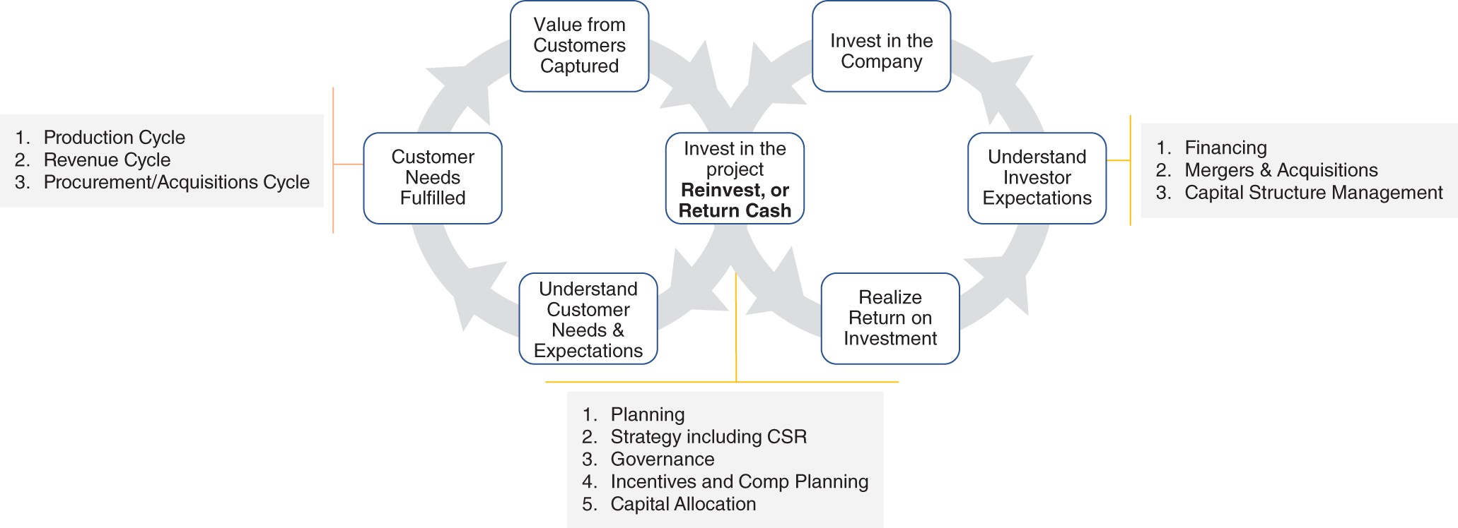
FIGURE 15.1 The Cycles of Audit

PRMIT Model
For each of the cycles in the Infinity Cycle, we can identify the automation strategy by defining the scope of automation with five integrated design elements. The five integrated design elements are known as the PRMIT model and they include predictors, risk, motivators, internal controls, and tests (see Figure 15.2).

Predictors include ratios, metrics, discovered relationships, and unspecified clusters as proxies to evaluate risk and strategy.
Risk involves assessing inherent risk for the cycle and developing a deeper understanding of assertions. Both risk assessment and assertion identification become dynamic (i.e., based upon the business conditions and the strategy of the firm, they are constantly updated).
Motivators are the behavioral elements and they include evaluating human behaviors related to the specific cycle. Human behavior analyses include using various data to predict and estimate the risk of errors and fraud. Motivations can be related to stock (capital markets) or contracts (i.e., anticipated benefits from misstating earnings like bonuses, avoiding triggers of debt covenants) (Amiram et al., 2018).
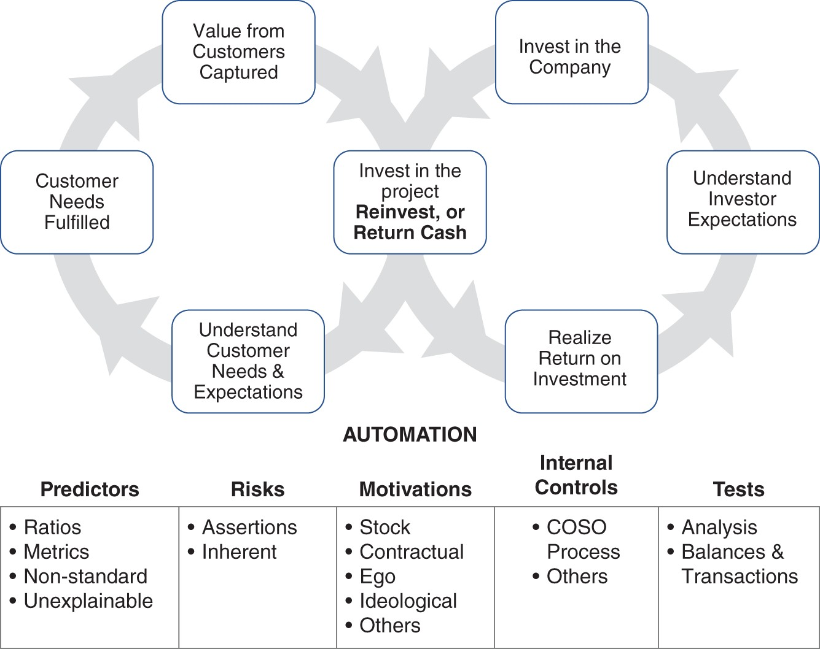
FIGURE 15.2 The PRMIT Model
Internal Controls implies observing and analyzing the internal controls within each cycle. This includes understanding the structural elements of the environment that may give rise to risk of error or fraud.
Tests are the procedures employed by audit or forensic firms and include analytical procedures and transactional/balance/entries‐level procedures.

For each cycle we recognize that our goal is twofold: first from a classic audit automation perspective where we can automate typical audit processes, and second from the business value

protection perspective. The second is about value destruction as a consequence of activities that will be classified as borderline illegal or operating at the edge of standards and law.
Using the PRMIT methodology we can now form a comprehensive plan of total audit and forensic automation for the various business management cycles.
Some of those cycles and their PRMIT analysis are discussed below. I will provide examples of Cash and Revenue cycles. Readers are encouraged to develop the PRMIT analysis for all cycles. (See Table 15.1.)
TABLE 15.1 The PRMIT Table

 | Predictors | Risks | Motivators | Int. Controls | Tests
Cash
Revenue
Production
Procure/SC
Financing
M&A
Cap Structure
Planning
Strategy
Governance
Incentives
Capital

Example of Cash Cycle
In 2019, PwC launched a product, Cash.ai, an intelligent automation model that automates the audit of the entire cash cycle of a firm. The company claims the following on its website (PwC, 2019):
PwC's Cash.ai uses AI to automatically read, understand and test client documents, including reported cash balances, bank reconciliations, bank confirmation letters, foreign exchange and financial condition of the bank – in essence, the complete audit of cash.
Cash‐related evidence includes documents such as bank statements, checks, cash receipt journal, cash disbursement journal, and others.
Cash‐related audit processes ensure proper internal controls and substantive testing of cash includes bank reconciliations, account balance assessments, inspection of checks, foreign currency implications, and other legal obligations associated with cash (e.g., endowments or financing‐related minimum cash balance that must be maintained). See Table 15.2 for a simple PRMIT analysis of Cash. As mentioned before the machine learning solution has both evidence reading and collection, as well as testing done to assess cash‐related internal controls. Other forensic‐centric tests may include counting cash, determining the net assets of the management team, and looking at how much money they spend on a monthly basis.

Example Revenue Cycle
The Revenue Cycle includes key Infinity Cycle processes, including customer orders, credit authorization, delivering products and services, billing, and collection. Customer master data, sales systems (Customer Relations Management CRM), billing system, pending orders, and inventories are all part of the revenue audit. See Figure 15.3.
TABLE 15.2 Cash PRMIT Analysis

 | Predictors | Risks | Motivators | Internal Controls | Tests
Cash | Revenues Capex | Existence Presence | Self‐ enriching | Access Responsibility | Reconciliation Documents
 | Inventories | Disclosures | Stealing | Structure
 | AR | Presentation |  | Others
 | Ratios | Value
 |  | Constraints
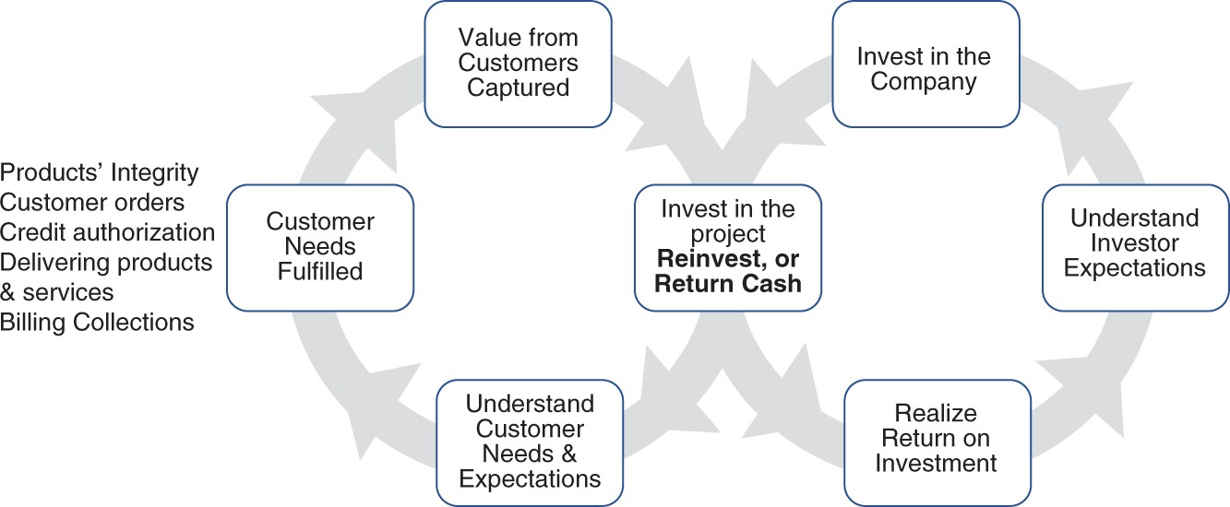
FIGURE 15.3 Revenue Cycle Processes
In general, the assurance interests are to evaluate that revenues did happen, they happened with the right parties, their quality was good, they were based upon actual products and services sale, they were recorded in the right time period, they were not stated under or over, and they were recorded in the appropriate accounts. The revenue cycle is at the heart of a company's operations and the survival of the entity depends upon that.
There are several key processes in the revenue cycle.

Product Integrity: Product Integrity refers to the firm selling legitimate products and services, that it is not a Ponzi scheme, or that it is not based upon known product deficiency. For example, VW continued to sell cars while knowing that its cars were not compliant with the environmental standards. Legitimacy of what is being sold and

marketed is often not evaluated in the audits. It is a critical element of quality of revenues and quality of earnings. The evaluation includes the assessment that the product or service is one‐time, growing, or dying. Both social media and financial statements of a firm can help evaluate if the firm is offering legitimate products and services. Complaints lodged with the regulatory agencies, whistleblower cases, and even rumors provide important source of data to evaluate.
Customer Orders: Customer orders data can show inconsistencies, trends, and relationships about the authenticity of customers. It can also reveal information about returns or sustainability of revenues. Knowledge of who the customers are is key to this inquiry. In financial industry, the regulatory requirement and best practice of Know Your Customer can be applied in other sectors as well. From a forensic and auditing perspective, this knowledge is critical to identify and uncover schemes where fake customers are used to manipulate revenues or where sales are made in a manner that the sales do not involve permanent value transfer from both sides. Fake sales and fake customers are discoverable by applying the PRMIT model.
Credit Authorization: Authorizing credit is critical to evaluate if the company will be able to collect cash from sales. It also indicates if proper authorizations were obtained to grant credit. This is closely related to how well we know our customers. Machine learning is widely used for credit risk management. A dynamic system will constantly update information about customers in a manner that provides greater insights to manage credit risk (Khandani et al., 2010; Su et al., 2019).
Delivering Products and Services: The various PRMIT‐based design concepts for products (and services) are related to proper transfer of value where the value gets transferred based upon legitimate products and services, without misleading marketing to the customers, with proper custody transfer, going to legitimate customers, and without anyone in the value chain stealing or diminishing value during the transfer. This process is managed by various documents, including shipping orders, bills of lading, various contracts, packing slips, and other shipment documents.
Billing: At the center of billing is the invoicing process. From a PRMIT perspective, several predictors of revenues and accounts receivable can be deployed to assess invoicing problems. The risk of changing the invoice or manipulating accounts receivable or inventories exists. The motivations, among others, can be to overcharge a client or hide money received. The automation of motivation can reveal how much motivation exists in the management and related parties to conduct billing fraud. The AR record itself is a source of value for the firm. Automation of billing audit and forensic analysis includes automated analysis of internal controls, automated incorporation of predictors and motivators in developing an understanding of billing-related misconduct, developing an ongoing risk profile, and automating the procedures and tests.
Collections: Being able to convert a sale into cash received by a firm is an important element to ongoing concern status of a firm. Automation of this process involves predicting the collections efficiency, timeliness, and accuracy. Motivators may include the assessment of hiding money, inflating AR, giving write‐offs to related parties, and others.

ROBOTS: A REVIEW
Most of our discussion has been about machine learning's applications as a software. The modern AI field in business applications includes several technologies, such as autonomous vehicles, robots, and drones. While each one of them is very different from the others, most of the artifacts that have a physical component and mobility can be viewed as a form of robot.
Retailers (for example, Walmart) have started to use robots for performing inventories in stores. Drones are also used to perform physical counts or estimate valuation of assets. For example, by flying a drone over properties, it could be possible to estimate the value of the properties by looking at the state of their property (lawn maintenance, roof, etc.).
Robots in movies are often shown as hominoid robots. The word robot comes from the Czech language, where it means “servant.” It can be defined as a machine that can sense, think, and act in its environment and pursue its goals. A normal non‐autonomous car is not considered a robot because it does not have any autonomy. This means that to be considered a robot, a machine must have at least some level of autonomy. Being able to perform work autonomously, that is, without human help, is an important part of being a robot.
Robots can be electromechanical or virtual. They can also be biological. In business we use electromechanical robots to conduct operations such as production, warehouse management, and autonomous cars. Robots can be classified by their use or mode of locomotion. Based upon that criteria, the following are some types of robots:

Stationary: These robots perform their work from a single point where they stay at a fixed position. They can move their arms or along rails.
Wheeled: Wheeled robots can move around. They are mounted on motor-powered wheels that enable them to move on surfaces. Walmart's robot is of this type. They can also have tracks or belts (such as in construction equipment or tanks) to move them.
Legged: Robots can have legs. They can mimic bipedal humanlike movement or have multiple legs like a dog or a spider.
Swimming: This robot type can move on the surface or underneath water. They can be viewed as autonomous boats, ships, or submarines.
Flying: Flying robots are drones. They can fly like an airplane and perform the tasks given to them. They use propulsion wings or propeller blades to fly.
Swarm: Swarm robots can be any of the above, except they function in a collaborative manner. They can be viewed as an ant or bee colony. They communicate with each other, function as a single entity, accomplish their tasks jointly, and cooperate and collaborate with each other,
Small, Mini, Micro, Milli, and Nano robots: These are tiny robots. A nanorobot is at or below 1 micrometer. A microrobot is less than 1 millimeter. A millirobot is at or below 1 cm. A minirobot is at or below 10 cm. A small robot is at or less than 100 cm. These robots can be useful in many types of business and other applications. For example, a swarm of microrobots can be used to explore areas that are dangerous for humans to explore.

Robots have several parts, including:

Sensors: Sensors are like the eyes, ears, and nose in humans. They bring in information from the environment. This information is used by a robot to understand its environment and to react to the sensor information received in accordance with its goals. Some examples of sensors are speed sensors, temperature sensors, light sensors, pressure sensors, sound sensors, and ultrasonic sensors.
Effectors: Effectors create an effect on the environment in which a robot operates. The legs, arms, wheels, and fingers are the effectors. In a physical robot, the movements or effects are obtained by motors and hydraulic cylinders.
Actuators: Actuators are the motors and hydraulic cylinders – the parts that make effectors do things. These parts convert energy so the robot can perform work.
Manipulators: Manipulators are like joints and links in human arms.
End Effectors: They are at the ends or tips of effectors. They can be viewed as fingertips or a palm in a human hand.
Locomotion: It refers to the parts that work together to make a robot move from one point to another. It may involve bipedal walking, running, rolling, swimming, hopping, etc.
Locomotion parts achieve integrated response to the mode of movement in a robot. They can include electric, hydraulic, or pneumatic motors.
Controller: Analogous to the human brain, controller is the brain of the robot. It receives information from sensors, processes it, and decides what actions to take in accordance with its goals.
Power supply: Robots use a power supply such as batteries.

Notice that learning algorithms are being applied in all of the above parts. For example, they are applied in various areas to improve or optimize performance (e.g., computer vision to make better sensors or in robotic navigation) (Li, 2018).
Key Points
The operations loop has three cycles: Revenue Cycle, Production Cycle, and Procurement/SC Cycle. The Investment Loop has three cycles: Financing, M&A, and Capital Structure Management. The Control Loop has Planning, Strategy, Governance, Incentives and Compensation, and Capital Allocation. PRMIT analysis has Predictors, Risks, Motivations, Internal Controls, and Tests to enable an organization to develop automation strategy.

REFERENCES
Amiram, D., Bozanic, Z., Cox, J. D., Dupont, Q., Karpoff, J. M., and Sloan, R. (2018) Financial reporting fraud and other forms of misconduct: A multidisciplinary review of the literature. Review of Accounting Studies, 23 (2): 732–783.

Chen, J. V. and Li, F. 2013. Estimating the amount of estimation in accruals. Working paper. Available from: https://www.fox.temple.edu/cms/wp-content/uploads/2013/03/Estimating- Estimation-v49-Feb-2013.pdf.
Ding, K., Lev, B., Peng, X., Sun, T., and Vasarhelyi, M. A. (2019) Machine learning improves accounting estimates, [online]. Available from: https://ssrn.com/abstract=3253220.
Khandani, A. E., Kim, A. J., and Lo, A. W. (2010) Consumer credit‐risk models via machine‐ learning algorithms. Journal of Banking and Finance, 34 (11): 2767–2787. Available from: http://dx.doi.org/10.1016/j.jbankfin.2010.06.001.
Li, Y. (2018) Deep reinforcement learning: An overview. Lecture Notes in Networks and Systems, (16): 426–440.
PwC (2019) Harnessing AI to pioneer new approaches to the audit [online]. Available from: https://www.pwc.com/gx/en/about/stories-from-across-the-world/harnessing-ai-to-pioneer- new-approaches-to-the-audit.html (accessed 11 April 2019).
Su, C., Tu, F., Zhang, X., Shia, B., and Lee, T. (2019) A Ensemble machine learning based system for merchant credit risk detection in merchant MCC misuse. Journal of Data Science, 17 (1): 81–106.

OceanofPDF.com

